Cancel Order & Quote by Users Design

Overview

Current processing
Currently the process of cancellation of order is done from User Management and cancellation of quote is done from Trader GUI using Market Display.

Existing process doesn’t work well when there is an urgent need for cancelling Quote & orders for a group of users. So when a client firm makes this cancel request, the HD must cancel these groups of userids one userid at a time.

New requirement

The Help Desk Enhancements project outlines specific requirements for user group:
1. Cancel quotes.
2. Cancel orders.
3. Get count for active quotes.
4. Get count for active orders.

To expedite the canceling of orders & quotes for groups of userids, the SAGUI was modified to provide the capability to initiate requests of multiple users within the same request to the BCs. These groups are maintained using the GroupService, which created as part of this project - see vob \documents\SBT\HelpDeskEnhancements\HDE - GroupService Design.doc for further details.
The requests for cancels or active count are routed from the SAGUI, to the SACAS, to the FE, and ultimately BC where the cancellation/counting of the orders and quotes for the specified users is executed. Noteworthy functionality in this process includes:
- The FE returns a preliminary list of BC servers that were sent the request back to the requesting SAGUI via the SACAS for status tracking purposes.
- The BC sends the results back to the SAGUI via the event channel.
- The cancel request and a record of all the orders & quote cancels are stored in the BCs local database. The request for active count for order & quote are not stored.

The following summarizes the new and modified SACAS , FE, and BC software resulting from this implementation.

Implementation

BulkTask (BC)
Marker interface type to model all federated tasks.

OrderHandlingServiceRoutingProxy(FE)
Routing proxy that delegates the incoming requests to the appropriate order handling service.
- public ServerResponseStruct[] cancelOrdersForUsers(RoutingParameterStruct routingParams, String userIdRequestingCancel,String[] userIds, String transactionId, DateTimeStruct timestamp,KeyValueStruct[] properties, short operationType):-Delegate the cancel order request to executeBulkServiceRequest().

- public ServerResponseStruct[] getOrderCountForUsers(RoutingParameterStruct routingParams,String userIdRequestingCancel,String[] userIds, String transactionId,DateTimeStruct timestamp,KeyValueStruct[] properties, short operationType):- Delegate the Order count request to executeBulkServiceRequest().

- private ServerResponseStruct[] executeBulkServiceRequest(RoutingParameterStruct routingParams,String userIdRequestingCancel,String[] userIds, String transactionId,DateTimeStruct timestamp, KeyValueStruct[] properties, short operationType,String requestType) :-Delegate the task [Order Cancel,Order Count] to Order Handling Services.routeMap is used to find valid services for order handling.

OrderHandlingServiceHomeImpl(BC)
This class is used to create and find an appropriate OrderHandlingService.It initalizes the thread pool for OrderHandlingService.
- private ExecutorService threadPoolService = null;:- Thread pool Reference. All the task are submitted to this pool
- protected synchronized ExecutorService getThreadPoolService():-Gets the Thread pool executor service.
- protected boolean isThreadPoolShutdown():-Returns "true" if the pool running, otherwise "false"
- public String adminSetCancelBulkControlRate(String p_cancelBulkSize,String p_cancelBulkWait):- Ar command for Setting values to control bulk order cancels rate

OrderHandlingServiceImpl(BC)
This class is OrderHandlingService implementation. It accepts orders, update, cancel and cancel/replace requests and defines various getters for retrieving orders. It will create the Bulk task & submit to the Thread Pool where the task gets executed asynchronously.
- private ExecutorService threadPoolExecutorService = null:-executor service to process group cancel order.
- private int orderCancelThreadPoolSize = 1:- ThreadPoolSize
- private int cancelBulkSize = 100:- CanncelBulkSize
- private int cancelBulkWait = 20:- CancelBulk wait time
- public ServerResponseStruct[] cancelOrdersForUsers(RoutingParameterStruct routingParams, String userIdRequestingCancel, String[] userIds, String transactionId, DateTimeStruct timestamp,KeyValueStruct[] properties, short operationType):- Create instance of BulkOrderTask & submit it to the Thread Pool.Returns "Task submitted to the pool" to SACAS.
- public ServerResponseStruct[] getOrderCountForUsers(RoutingParameterStruct routingParams, String userIdRequestingCancel, String[] userIds, String transactionId, DateTimeStruct timestamp, KeyValueStruct[] properties, short operationType):-Create instance of OrderCountTask & submit to the thread pool.Returns "Task submitted to the Pool" to SACAS.
- public ExecutorService getThreadPoolExecutorService(): Get Thread Pool service from Home.

OrderHandlingServiceHelper(BC)
This class acts as a helper class to OrderHandlingServiceImpl.
- public static List<Order> findAllOrdersForUsers(String[] userIds,OrderHome theOrderHome):- Utility method to find all orders for the users. If the total number of userIds is > 1000, the find operation will be performed in sets of 1000s.

- private static Order[] findOrdersForUsers(String[] users,OrderHome orderHome):- Internal helper method to find orders for the users.

- public static List<Order> filterOrders(List<Order> ordersToFilter, short operationType):- Utility method to filter only orders or quote like orders (i.e., I-Orders) based on the operation type.

- private static boolean isOrder(Order order):- Internal helper method to check whether an order can be cancelled.
- private static boolean isIOrder(Order order):- Internal helper method to check whether an I-Order can be cancelled.
- private static boolean isOrderActive(Order order):- Internal helper method to check whether an order is active.
- public static String getCancelStatus(Order orderToCancel):- Helper method to determine the cancel status.
- public static CancelRequestStruct buildCancelRequestStruct(Order orderToCancel):- Helper method to build the CancelRequestStruct.
- public static String getOperationType(final short operationType):- Helper method to determine the type of operation.

- public static void persistBulkActionDtl(List<BulkActionDetailWrapper> cancelDetails,BulkActionDtlHome bulkActionDetailHome):- Utility method to persist the details of cancel summary.
- public static void validateOperationType(short operationType) throws DataValidationException:- Utility method to validate the operation type

CancelOrderTask(BC)
Task for cancelling the orders, for a given group of users or a single user.
- public CancelOrderTask(OrderHandlingService orderHandlingService,OrderHome orderHome,
BulkActionDtlHome bulkActionDetailHome, BulkActionRequestHome bulkActionRequestHome,
SystemControlConsumerHome systemControlConsumerHome, String userIdRequestingCancel,
ProductDataCache productDataCache, String[] userIds, String transactionId, String serverName,
DateTimeStruct timeStamp, KeyValueStruct[] properties, int cancelBulkSize,int cancelBulkWait, final short operationType):- Creates new group cancel order task.
- private void cancelOrderForUsers():-Cancels all orders for a given set of users
- private List<BulkActionDetailWrapper> cancelOrders(List<Order> ordersToCancel,BulkActionRequest request):-Cancel Orders

OrderCountTask(BC)
Task for finding the total no. of active orders or I-orders, for a given group of users or a single user.
Public OrderCountTask(SystemControlConsumerHome systemControlConsumerHome, String[] userIds,OrderHome theOrderHome, String transactionId, String serverName, KeyValueStruct[] properties, short operationType) :- Creates task for finding the no. of active orders or I-orders

MarketMakerQuoteServiceRoutingProxy(FE)
This class is a routing proxy that delegates the incoming requests to the appropriate BC.
- public ServerResponseStruct[] cancelQuotesForUsers(RoutingParameterStruct routingParams, String userIdRequestingCancel, String[] userIds, String transactionId, DateTimeStruct timestamp, KeyValueStruct[] properties) :-Delegate the cancel order request to executeBulkServiceRequest().
- public ServerResponseStruct[] getQuoteCountForUsers(RoutingParameterStruct routingParams, String userIdRequestingCancel, String[] userIds, String transactionId, DateTimeStruct timestamp, KeyValueStruct[] properties) :-Delegate the cancel order request to executeBulkServiceRequest().
- private ServerResponseStruct[] executeBulkServiceRequest(RoutingParameterStruct routingParams, String userIdRequestingCancel, String[] userIds, String transactionId, DateTimeStruct timestamp, KeyValueStruct[] properties, String requestType) :- Delegate the task [Quote Cancel,Quote Count] to Market maker Quote Service .routeMap is used to find valid services.

MarketMakerQuoteServiceHomeLocalImpl(BC)
This is the home for the Market Maker Quote Service and is used to create and find the MarketMakerQuoteService.It initializes the thread pool service for Market Maker Quote Service.
- private ExecutorService threadPoolService = null;:- Thread pool Reference. All the task are submitted to this pool
- protected synchronized ExecutorService getThreadPoolService():-Gets the Thread pool executor service.
- protected boolean isThreadPoolShutdown():-Returns "true" if the pool running, otherwise "false"

MarketMakerQuoteServiceLocalImpl (BC)
This class represents the actual implementation of the MarketMakerQuoteService.It will create the Bulk task & submit to the Thread Pool where the task gets executed asynchronously.
- private ExecutorService threadPoolExecutorService = null:-executor service to process task.
- private int orderCancelThreadPoolSize = 1:- ThreadPoolSize
- private int cancelBulkSize = 100:- CanncelBulkSize
- private int cancelBulkWait = 20:- CancelBulk wait time
- public ServerResponseStruct[] cancelQuotesForUsers(RoutingParameterStruct routingParams,String userIdRequestingCancel,String[] userIds, String transactionId,DateTimeStruct timestamp, KeyValueStruct[] properties):- Create instance of CancelQuoteTask& submit it to the Thread Pool.Returns "Task submitted to the pool" to SACAS.
- public ServerResponseStruct[] getQuoteCountForUsers(RoutingParameterStruct routingParams,String userIdRequestingCancel,String[] userIds, String transactionId,DateTimeStruct timestamp, KeyValueStruct[] properties):-Create instance of QuoteCountTask & submit to the thread pool.Returns "Task submitted to the Pool" to SACAS.
- public ExecutorService getThreadPoolExecutorService(): Get Thread Pool service from Home.

MarketMakerQuoteServiceHelper(BC)
This class acts as a helper to federated operations on Quote Service.
- public static QuoteHome getQuoteHome():-Returns a handle to the QuoteHome.
- public static BrokerService getBrokerService():-Returns a handle to the BrokerService.
- private static BrokerServiceHome getBrokerServiceHome():-Returns a handle to the
- BrokerServiceHome.
- public static int findAllActiveQuotesForUsers(String[] userIds) throws Exception:- Helper method to find all active Quote for a given a given array
- of userIds.
- public static int getFailedQuotesCount(Quote[] quotesToCancel) throws Exception:- Helper method to find the number of failed quote cancels.

CancelQuoteTask (BC)
Task for cancelling the quotes, for a given group of users or a single user.
- public CancelQuoteTask(SystemControlConsumerHome systemControlConsumerHome, MarketMakerQuoteServiceLocalImpl marketMakerQuoteServiceLocal, BulkActionRequestHome bulkActionRequestHome, String userIdRequestingCancel, String[] userIds, String transactionId,String serverName, DateTimeStruct timestamp, KeyValueStruct[] properties, int cancelBulkSize, int cancelBulkWait)
- private void cancelQuotesForUsers():-Cancels all quotes for a given set of users,persist the result and publish it.

QuoteCountTask(BC)
Task for finding the total no.of active quotes, for a given group of users or a single user.
- public QuoteCountTask(SystemControlConsumerHome systemControlConsumerHome,String[] userIds, String transactionId, String serverName, KeyValueStruct[] properties) :- Creates a new task for finding the no. of quotes.
- public void run():-Find all the active Quotes and do the publish.

FederatedServiceHelper(BC)
Base Helper class to render all common functionalities and validations to process federated requests. This helper class also has the auditing methods for bulk Order Cancels.

- public static String getValueFromKeyValueStruct(final KeyValueStruct[] properties, final String key) :- Utility method to fetch the value of a given key from the KeyValueStruct> array.

- private static String prepareOptionalText(final KeyValueStruct[] properties) :- Utility method to prepare the optional text for a certain federated request

- public static SummaryStruct prepareFederatedResponseSummaryStruct(final int successfull,
final int activeQuantity, final int failed, final String transactionId, final String serverName,
final KeyValueStruct[] properties, final short operationType) :- Utility method to prepare the SummaryStruct for federated responses through even channel

- public static BulkActionRequest persistBulkActionRequest(final BulkActionRequestHome bulkActionRequestHome, final DateTimeStruct timeStamp, final String userIdRequestingCancel, final String requestType, final String transactionId, final String serverName, final KeyValueStruct[] properties) :- Utility method to save the request information to the persistence layer

- public static List<String> getServiceRoutes(Map routeMap) :- Utility method to get the list of BC's and eliminate the underlying service.

- private static boolean isValidBCCall(String serviceRoute) :- Internal helper method check whether a given service name is that of an underlying session.

- public static boolean isStringEmpty(String value) :- Helper method to check if a given string value is empty.

- public static ServerResponseStruct getServerResponseStruct(String serverId, short errorCode, String description) :- Helper method to construct the ServerResponseStruct with the given input parameters.

- public static void validateUserIdRequestingCancel(final String userIdRequestingCancel) throws DataValidationException :- Helper method to validate the unique identifier of the user

- public static void validateUserIds(final String[] userIds) throws DataValidationException :- Helper method to validate the unique identifier of the users whose orders/quotes bulk request is received

- public static void validateWorkstationID(final KeyValueStruct[] properties, final String key) throws DataValidationException :- Helper method to validate the workstartionID for a bulk request

- public static void validateOperationType(short operationType) throws DataValidationException :- Utility method to validate the operation type

Configrations
  - OrderHandlingService
- XML File: OrderHandlingService.xml
<OrderHandlingServiceHomeImplProperties>
<orderCancelThreadPoolSize>1</orderCancelThreadPoolSize>
<cancelBulkSize>10</cancelBulkSize>
<cancelBulkWaitMillis>100</cancelBulkWaitMillis>
</OrderHandlingServiceHomeImplProperties>
- AR Command
ar $SERVER_NAME setCancelBulkControlRate $CancelBulkSize $CancelBulkWait
e.g
ar TradeServer2 setCancelBulkControlRate 150 30
  - MarketMakerQuoteService
- XML File: MarketMakerQuoteService.xml
<MarketMakerQuoteServiceHomeLocalImplProperties> <quoteCancelThreadPoolSize>1</quoteCancelThreadPoolSize>
<cancelBulkSize>100</cancelBulkSize>
<cancelBulkWaitMillis>20</cancelBulkWaitMillis>
</MarketMakerQuoteServiceHomeLocalImplProperties>
- AR Command
ar $SERVER_NAME adminSetQuoteCancelBulkControlRate $CancelBulkSize $CancelBulkWait
e.g
ar TradeServer2 adminSetQuoteCancelBulkControlRate 150 30

IDL Changes – All Layers
OrderCancelSummaryStruct.idl – New :- holds cancel order summary data to be publish.
GroupCancelEventService.idl – New :- holds interface definition for GroupCancelEventService.
OrderHandlingService.idl: New exposed method for cancelOrderForUsers
Order.idl: Added OrderCancelSummaryStruct :- Holds transactionId, serverId, groupKey, number of orders, Requested/Cancelled/Failed.
constants.idl:- Added ServerResponseCodes, PropertyFederatedBulkOperation and FederatedOperationType
Util.idl:- Aded ServerResponseStruct, RoutingParameterStruct and SummaryStruct
CmiErrorCodes.idl:- SomeEntries for error codes
Consumer.idl:- Added acceptGroupCancelSummary() in interface SystemControlConsumer

XML/DTD/CSV/TXT Updates
MarketMakerQuoteService.xml/dtd :- Added threadpool configurations
ACL.csv :- Added cancelOrderForUsers, cancelQuotesForUsers, getQuoteCountForUsers & getOrderCountForUsers

SetContext

None

Homes/Services
- All listed above in implementation

ImplPlan
- None

PerformanceTestingProcedure
- None

TestingProcedure
- Please refer testing document ______________________

OperatorProcedure
- None.

Fallback/Failover
- List how fallback/failover will be achieved after rollout

Class Diagram.
Classes deployed at Front End (Routing) server
Routing proxy will get the request from System Admin Client application services (SACAS). These proxies will delegate the request to the Business Services (Trade servers). These proxies return ServerResponseStruct. GUI uses this structs to display number of Trader Server participating.
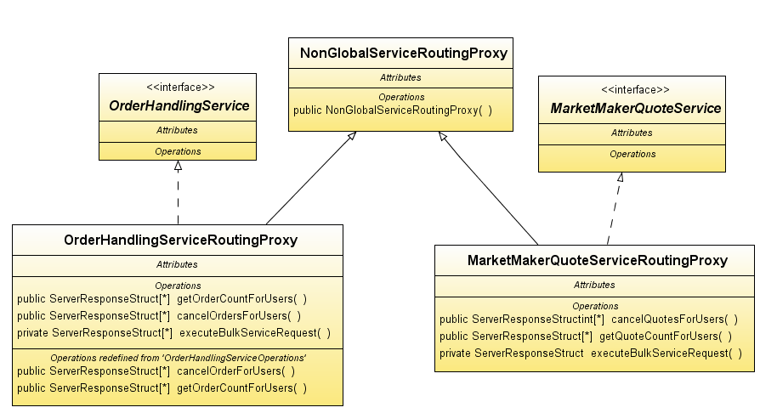

Classes deployed at Business Services.
Business service will get the request from Front End (Routing Proxy).These services will create the suitable bulk task and submit to the Thread pool. Both these services use separate Thread pools. In Thread pool task will be executed asynchronously. The output will be published to the Event Channel by using service of SystemControlConsumerHome.

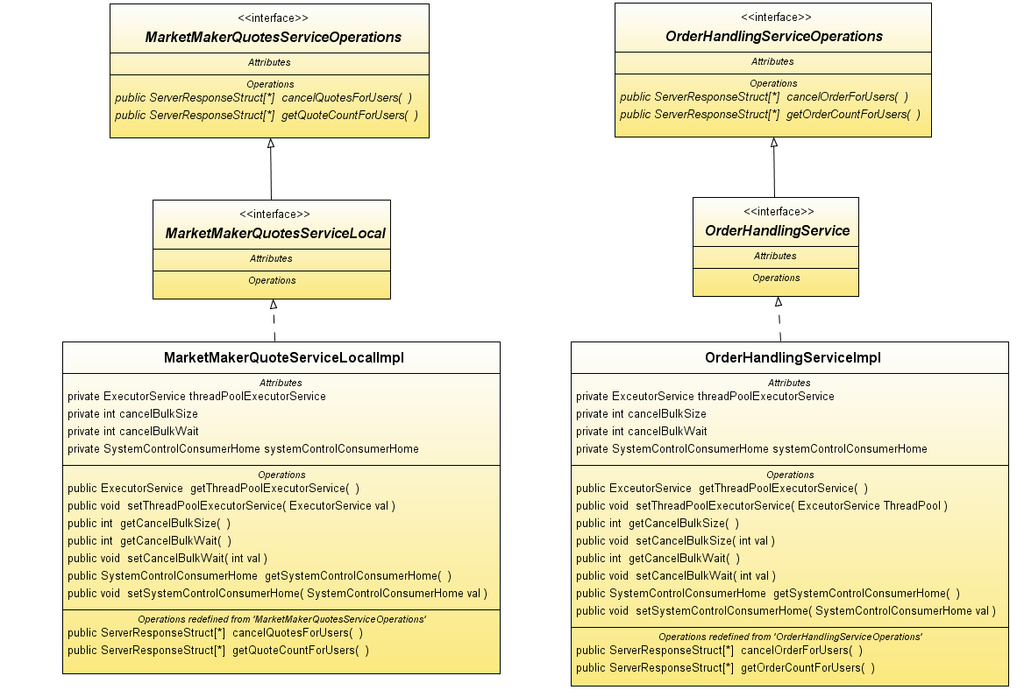

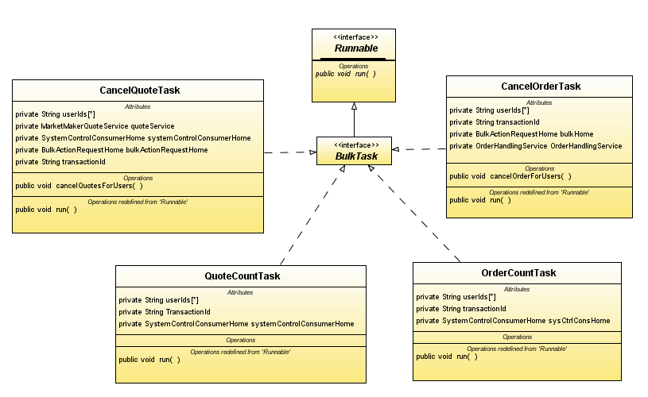

Above XXXXTask implements Bulk Task interface which extends Runnable interface. These tasks are executed asynchronously in the Thread Pool. The result is published to the Event Channel. Cancel Order task & Cancel Quote task uses Bulk Service to persist request & as well as response info in DB.

